East and Southeast Asia Map: Add the labels from the box to the map. Name: ____________________________
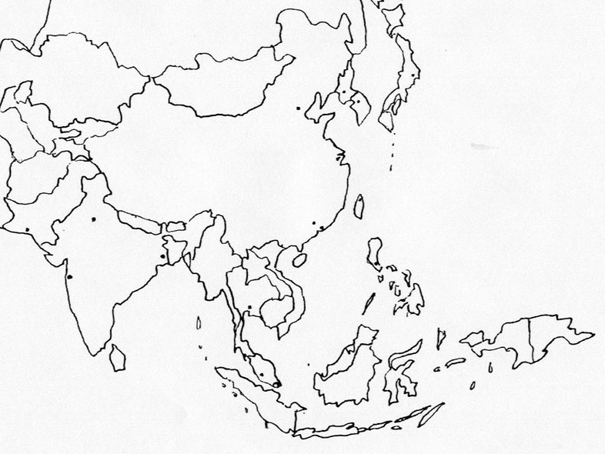
Countries: China, Japan, North Korea, South Korea, Mongolia, Taiwan, Bangladesh, India, Pakistan, Nepal, Bhutan, Sri Lanka, Brunei, Myanmar, Cambodia, Indonesia, Laos, Vietnam, Malaysia, Philippines, Singapore, Thailand, Russia, Timor-Leste, Papua-New Guinea
Cities: Tokyo, Karachi, Mumbai, New Delhi, Kolkata, Beijing, Bangkok, Kuala Lumpur, Shanghai, Manila, Taipei, Pyongyang, Seoul, Guangzhou, Hong Kong, Jakarta
Seas: Sea of Japan, East China Sea, South China Sea, Indian Ocean, Bay of Bengal

