The Geographer’s World: Unit 1
Dear Students: Our first unit this year will focus on geography. The activities will include geography terms, reading latitude and longitude, directions, interpreting and locating on a map. Please complete all work on your own paper.
Standard: GLE 1. Use different types of maps and geographic tools to analyze features on Earth to investigate and solve geographic questions.
Learning Goal: I will use different maps and geographic tools to identify the five criteria that all maps are required to have (T.O.D.A.L.S.).
__________ Activity 1- Please define the geography terms on your own paper. Check your answers when your work is complete. Correct any errors in your definitions. Write each word in a sentence to practice usage of the word. Study the terms for the Activity 1 Assessment.
__________ Activity 2- Please complete the activity on the world outline maps. Your map must be labeled in pencil. Check your answers when the work is completed. Study the locations and prepare for an Assessment on Activity 2.
__________ Activity 3A & 3B- Please complete Activity 3A and 3B on your own paper. You will need your geography textbook. Find the country nearest to the position. Check your answers. Prepare to take the test over Activity 3.
__________ Activity 4- Complete Activity 4 in packet. Follow the directions given on the sheet and research the map projections in your textbook. Check your answers. Prepare for Activity 4 test on map projections.
__________ Activity 5- Complete Activity 5 in packet. Follow the directions, 1. Define vocabulary, 2. Participate in group flashlight activity, 3. Finish questions in Activity 5.
__________ Activity 6 – Pop! Goes The World
__________ Activity 7- physical Features chapter 2 poster
__________ Activity 8- Types of maps
Remember: You must complete the Activity center work before you take the test for the center.

Geography Unit 1
Activity 1: Basic Vocabulary of the Geographer’s World
Directions: Please define each term using your geography textbook. After you define each of the terms, please use each term in a sentence that demonstrates to me that you know the meaning of the word. Check your answers when you complete the assignment. Study the terms in this activity, for a summative assessment on Activity 1. Look in pages 11-39 in your textbook.
- Absolute location  - Relative location  - Distortion  - Map projection  - Compass Rose  - Cardinal Directions  - Intermediate Directions  - Map Legend or Key  - Map Grid  - Parallels (Latitude)  - Meridians (Longitude)  - Prime Meridian  - International Dateline  - Equator  - Coordinates  - Scale | - Hemisphere  - Tropic of Cancer  - Tropic of Capricorn  - Sphere  - Continent  - Country  - Elevation  - Climate  - Economic Activity  - Landform  - Physical Feature  - Population Density  - Region  - Rotation  - Revolution  - Axis

Geography Unit 1
Activity 2: Locating Places Around the World
Directions: Please locate and label neatly the places listed below on your world map. Use the map on pages in your geography book. Your map must be labeled in pencil (pen is NOT ALLOWED). Check your answers with a partner. Study the locations and prepare for a summative assessment on Activity 2.
- Title the Map  - Orientation (draw a Compass Rose on map)  - Date Map  - Author (write your name in right hand corner of map)  - Equator (546 & 547)  - Tropic of Cancer (546 & 547)  - Tropic of Capricorn (546 & 547)  - Prime Meridian (546 & 547)  - International Dateline (411)  - Arctic Circle (546 & 547)  - Antarctic Circle (546 & 547)  - Locate and Label all 7 Continents (546 & 547)  - Locate and Label all 4 Oceans (546 & 547) | - Mediterranean Sea (570)  - Carribean Sea (564)  - Arabian Sea (582)  - South China Sea (589)  - Persian Gulf  - Persian Gulf (582)  - Black Sea (571)  - Ural Mountains (570)  - Alps (570)  - Himalayas (588)  - Andes (564)  - Caspian Sea (571)  - North Sea (570)  - Baltic Sea (570)  - Red Sea (577)  - Sahara Desert (576)  - Gobi Desert (588)  - Amazon River (564)  - Yangtze River (588)  - Nile River (576)

Geography Unit 1 (Absolute Location)
Activity 3A: Map Skills, Practicing Latitude and Longitude
Directions: Read pages 14-17 in your geography textbook before you begin the activity.
Definition: ° = Degrees
Country
- 40° North, 90° West (548-549) ________________________________
- 60° North, 60° East (548-549) ________________________________
- 30° South, 150° East (548-549) ________________________________
- 20° South, 50° West (548-549) ________________________________
- 10° North, 40° East (548-549) ________________________________
- 30° North, 30° East (583) ________________________________
- 50° North, 20° East (571) ________________________________
- 50° North, 10° East (571) ________________________________
- 20° North, 100° West (568) ________________________________
- 42° North, 15° East (571) ________________________________
- 66° North, 20° East (571) ________________________________
- 20° North, 80° East (588) ________________________________
- 30° North, 0° East (577) ________________________________
- 11° North, 108° East (589) ________________________________
- 22° North, 80° West (565) ________________________________
- 40° North, 30° East (583) ________________________________
- 35° North, 140° East (589) ________________________________
- 52° North, 1° West (571) ________________________________
- 30° South, 60° West (565) ________________________________
- 25° North, 110° East ________________________________
- 24° North, 48° East ________________________________
- 30° South, 20° East ________________________________
- 15° North, 120° East ________________________________
- 30° North, 65° East ________________________________
- 18° North, 75° West ______ __________________________
- 0° , 0° ________________________________
Geography Unit 1 (KEY)
Activity 3A: Map Skills, Practicing Latitude and Longitude
Directions: Read pages 14-17 in your geography textbook before you begin the activity.
Definition: ° = Degrees
Country
- 40° North, 90° West (548-549) U.S.
- 60° North, 60° East (548-549) Russia
- 30° South, 150° East (548-549) Australia
- 20° South, 50° West (548-549) Brazil
- 10° North, 40° East (548-549) Ethiopia
- 30° North, 30° East (583) Iraq
- 50° North, 20° East (571) Poland
- 50° North, 10° East (571) Germany
- 20° North, 100° West (568) Mexico
- 42° North, 15° East (571) Italy
- 66° North, 20° East (571) Sweden
- 20° North, 80° East (588) India
- 30° North, 0° East (577) Algeria
- 11° North, 108° East (589) Vietnam
- 22° North, 80° West (565) Cuba
- 40° North, 30° East (583) Turkey
- 35° North, 140° East (589) Japan
- 52° North, 1° West (571) England
- 30° South, 60° West (565) Argentina
- 25° North, 110° East China
- 24° North, 48° East Saudi Arabia
- 30° South, 20° East South Africa
- 15° North, 120° East Philippines
- 30° North, 65° East Afghanistan
- 18° North, 75° West Haiti
- 0° , 0° Atlantic Ocean (Bonus)
Activity 3B (Absolute Location) HOME WORK
Crack the Code
Your Mission
Crack the code to find out where the thieves are taking the loot. Crafty robbers broke into the Royal Geographical Society in London and stole armfuls of priceless maps. Finding them would be hopeless, except that they dropped a scrap of paper with some odd scribbles on it.
At the top is a rhyme that seems to be an instruction from the thieves’ boss:
“FIRST LETTERS FROM EACH PLACE-NAME READ: SPELL OUT THE TOWN AND COME WITH SPEED.”
Thanks to your brilliant detective skills, you realize that the coordinates are for cities all over the planet
- Find those places in an atlas or on a map.
- As you find each place, write its name next to the coordinates
- Circle the first letter of each name
- Read the letters top to bottom, and they should spell the name of a city.
- List the exact latitude and longitude for the final city.

Now you know where to nab those cartographic crooks.

LATITUDE LONGITUDE LETTERS

59°N 18°E __ __ __ __ __ __ __ __ __
21°N 106°E __ __ __ __ __
19°S 48°E __ __ __ __ __ __ __ __ __ __ __ __
30°N 90°W __ __ __ __ __ __ __ __ __ __
14°N 91°W __ __ __ __ __ __ __ __ __ __ __ __ __
60°N 24°E __ __ __ __ __ __ __ __
40°N 33°E __ __ __ __ __ __
34°N 72°E __ __ __ __ __ __ __ __ __
Final Destination ___________________________________________________________
Latitude and Longitude ______________________________________________________
Crack The Code KEY- 3B
Your Mission
Crack the code to find out where the thieves are taking the loot. Crafty robbers broke into the Royal Geographical Society in London and stole armfuls of priceless maps. Finding them would be hopeless, except that they dropped a scrap of paper with some odd scribbles on it.
At the top is a rhyme that seems to be an instruction from the thieves’ boss:
“FIRST LETTERS FROM EACH PLACE-NAME READ: SPELL OUT THE TOWN AND COME WITH SPEED.”
Thanks to your brilliant detective skills, you realize that the coordinates are for cities all over the planet
- Find those places in an atlas or on a map.
- As you find each place, write its name next to the coordinates
- Circle the first letter of each name
- Read the letters top to bottom, and they should spell the name of a city.
- List the exact latitude and longitude for the final city.

Now you know where to nab those cartographic crooks.

LATITUDE LONGITUDE LETTERS

59°N 18°E __ __ __ __ __ __ __ __ __ (Stockholm)
21°N 106°E __ __ __ __ __ (Hanoi)
19°S 48°E __ __ __ __ __ __ __ __ __ __ __ __ (Antananarivo)
30°N 90°W __ __ __ __ __ __ __ __ __ __ (New Orleans)
14°N 91°W __ __ __ __ __ __ __ __ __ __ __ __ __ (Guatemala City
60°N 24°E __ __ __ __ __ __ __ __ (Helsinki)
40°N 33°E __ __ __ __ __ __ (Ankara)
34°N 72°E __ __ __ __ __ __ __ __ __ (Islamabad)

Final Destination ____Shanghai, China __________________________________

Latitude and Longitude _____________________30 N, 121 E Shanghai___________
Geography Unit 1 (Relative Location)
Activity 4: Direction/Orientation
Directions: Please write down the state after reading the directions. Use the map on page 27you’re your geography textbook.
Part I
- What state is directly south of Utah and east of California?
- What states are directly north of Texas and south of Nebraska?
- What state is directly south of Wyoming and north of New Mexico?
- What state is directly east of North Dakota and south of Canada?
- What state is directly west of Mississippi and south of Arkansas?
- What state is directly north of Florida and east of Alabama?
- What state is directly south of Iowa and east of Kansas?
- What state is directly south of Washington and north of California?
- What state is directly west of Texas and east of Arizona?
- What state is directly south of South Dakota and north of Kansas?
Part II: Use pages 548 and 549 in your textbook.
- What country is directly east of Sweden and west of the Russian Federation?
- What country is directly east of Namibia and north of South Africa?
- What country is directly south of Venezuela and west of Guyana?
- What country is directly west of Spain?
- What country is directly east of Chile?
- What country is directly north of Saudi Arabia and west of Iran?
- What country is directly south of the U.S.?
- What ocean is directly west of North America?
- What ocean is directly east of Africa?
- What sea is directly north of Africa and south of Europe?
- (Bonus) What country is directly southeast of Sri Lanka and west of Papua New Guinea?

Geography Unit 1 (Relative Location)
Activity 4: Direction/Orientation (KEY)
Directions: Please write down the state after reading the directions. Use the map on page 27 in the geography textbook.
Part I
- What state is directly south of Utah and east of California? AZ
- What states are directly north of Texas and south of Nebraska? KS, OK
- What state is directly south of Wyoming and north of New Mexico? CO
- What state is directly east of North Dakota and south of Canada? MN
- What state is directly west of Mississippi and south of Arkansas? LA
- What state is directly north of Florida and east of Alabama? GA
- What state is directly south of Iowa and east of Kansas? MO
- What state is directly south of Washington and north of California? OR
- What state is directly west of Texas and east of Arizona? NM
- What state is directly south of South Dakota and north of Kansas? NE
Part II: Use pages 548 and 549 in your textbook.
- What country is directly east of Sweden and west of the Russian Federation? FINLAND
- What country is directly east of Namibia and north of South Africa? BOTSWANA
- What country is directly south of Venezuela and west of Guyana? BRAZIL
- What country is directly west of Spain? PORTUGAL
- What country is directly east of Chile? ARGENTINA
- What country is directly north of Saudi Arabia and west of Iran? IRAQ
- What country is directly south of the U.S.? MEXICO
- What ocean is directly west of North America? PACIFIC OCEAN
- What ocean is directly east of Africa? INDIAN OCEAN
- What sea is directly north of Africa and south of Europe? MED SEA
- (Bonus) What country is directly southeast of Sri Lanka and west of Papua New Guinea?
SINGAPORE

Geography Unit 1
Activity 4: Map Projections
Directions: Read pages pg. 22-23 in your geography textbook before you begin the activity. After you complete the front of this, draw an image of each kind of map on the back and point to one strength and one weakness of each map.
Type of Map/What it’s Used For | Strengths of This Type of Map | Weaknesses of This Type of Map
Lambert  Projection | At the North Pole and the South Pole the land is NOT distorted. It is accurate in the center. | The land near the equator is distorted.
Mercator Projection

Eckert IV Projection

Goode’s Homolosine Projection

Geography Unit 1

Activity 5, Reasons for the Seasons: Page 20-21
1.
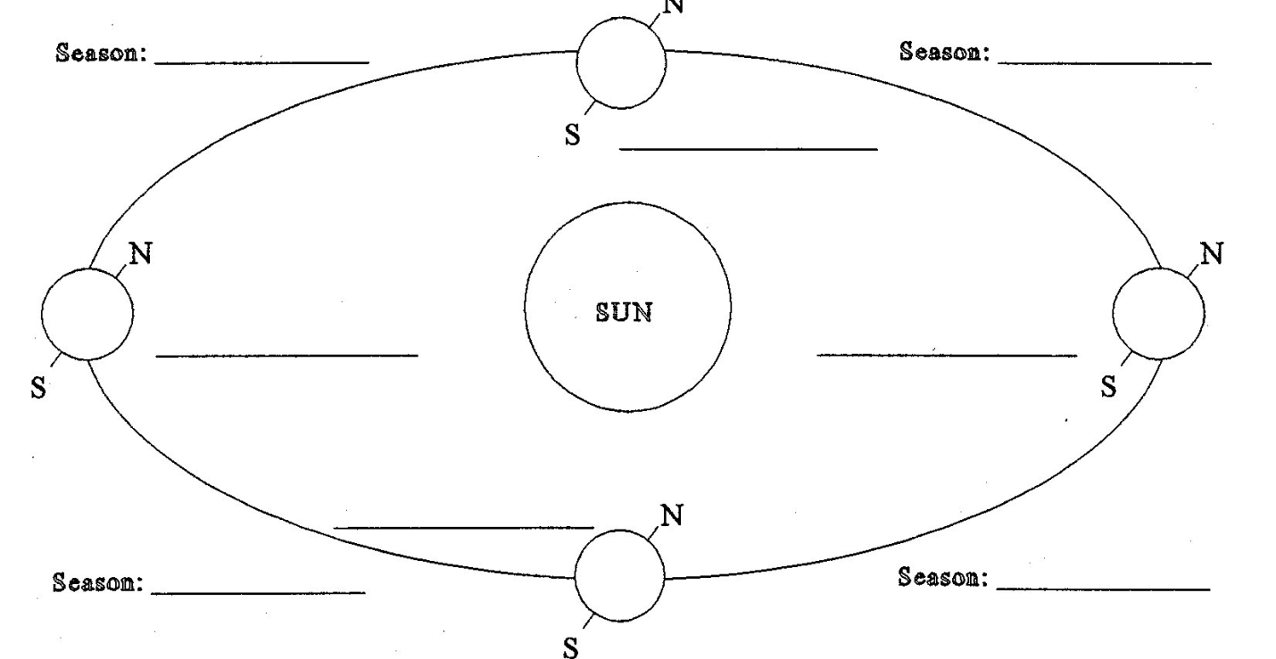
Vocabulary: autumnal equinox, vernal equinox, summer solstice, winter solstice

2. Tilt determines the seasons. At what angle is the Earth tilted at with respect to the Sun? ___ degrees
3. What season does not exist along the Equator? Why?

4. If it is winter in the Southern Hemisphere, then it is __________________ in the Northern Hemisphere.
5. If it is autumn in the Northern Hemisphere, then it is _______________ in the Southern Hemisphere.
6. Critical Thinking: Describe the summer and winter at one of the poles

Geography Unit 1
Activity 6- Pop Goes the World
Directions:
- Mark and label the North Pole and South Pole
- Draw the Equator (straight line)
- Draw the Prime Meridian (use dashed)
- Draw (dotted line) . . . . . Tropic of Capricorn and the Tropic of Cancer
- Draw and label all 7 seven continents
- Label of oceans
- Put an x where you live
- Put a star on three places you want to go
- Put a unhappy face on a place you don’t want to
- Last instruction- pop the world

